DVP interface

Overview
DVP interface contains up to 2 DVP input (BT656/BT1120/BT601), 1 DVP output for BT656/BT1120/BT601, 1 RGB (24bit RGB data) LCD output.

Architecture
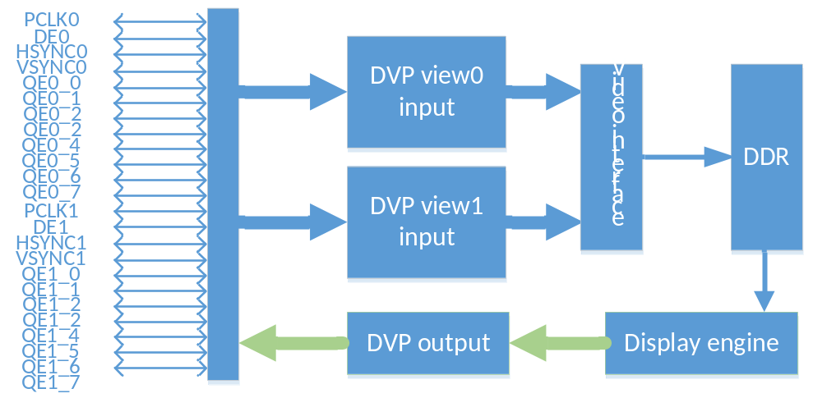
DVP Interface Structure

Functional description
DVP interface support up to 2 DVP input (BT656/BT1120/BT601), up to 1080p@60fps
Support 1 14bit camera interface up to 1080p@60fps
Support 1 DVP output for BT656/BT1120/BT601, up to 1080p@60fps
Support 24bit RGB parallel interface LCD panel, up to 1080p@60fps

